Backend System Architecture (Modular Monolithic)
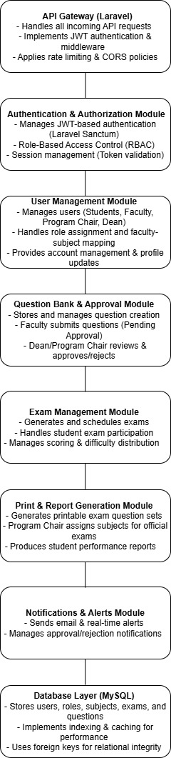

Detailed Explanation of the Modular Monolithic Backend System Architecture for CAPS
This backend architecture follows a Modular Monolithic approach, where different functionalities are split into separate modules but still operate within a single Laravel application. This ensures maintainability, security, and scalability while keeping the system efficient and easy to manage.

1️. API Gateway (Laravel)
Purpose: The entry point for all frontend requests and external API calls.
Responsibilities:
- Handles all incoming API requests from frontend clients (web app, mobile app).
- Implements JWT authentication (via Laravel Sanctum).
- Applies middleware for security (CORS, rate limiting).
- Routes requests to the correct module based on the request type.
How it Works:
- The frontend sends a request (e.g., user login, fetch questions, submit an exam).
- The API Gateway validates authentication (via JWT token).
- If the request is authorized, it is passed to the relevant module.
- The module processes the request and sends a response back.

2️. Authentication & Authorization Module
Purpose: Ensures that only authenticated and authorized users can access the system.
Responsibilities:
- JWT-based authentication (via Laravel Sanctum).
- Role-Based Access Control (RBAC) for users (Student, Faculty, Program Chair, Dean).
- Session management (token validation and expiration).
- Encrypts passwords using Laravel’s Hashing system.
How it Works:
- A user logs in and receives a JWT token.
- The token contains role-based access data (e.g., "role": "Faculty").
- All future requests must include the token in the Authorization: Bearer {token} header.
- Middleware verifies the token and checks user role before processing.
Security Features:
- Token Expiration → Prevents long-term unauthorized access.
- Rate Limiting → Prevents brute-force attacks.
- CORS & CSRF Protection → Ensures secure API requests.

3️. User Management Module
Purpose: Handles user registration, profile management, and role assignments.
Responsibilities:
- Manages students, faculty, program chairs, and deans.
- Assigns roles and permissions dynamically.
- Handles faculty-subject assignments (which faculty manages which subjects).
- Provides an admin panel for managing user accounts.
How it Works:
- An admin (Dean) assigns roles to new users.
- Faculty members are linked to subjects for question creation.
- Users can update their profiles (change password, update email, etc.).
- The system ensures only authorized users can access or modify user data.

4️. Question Bank & Approval Module
Purpose: Manages question creation, approval workflow, and modifications.
Responsibilities:
- Faculty submits questions (Pending Approval status).
- Program Chair/Dean reviews and approves/rejects questions.
- Tracks modifications to questions and choices.
- Stores difficulty level and coverage type (e.g., Midterm, Final).
How it Works:
- A Faculty member creates a new question.
- The question is submitted for approval (Pending status).
- The Program Chair or Dean reviews the question.
- If approved, the question is available for exams.
- If rejected, the faculty must revise the question before resubmitting.
Security Features:
- Versioning → Keeps track of modified questions.
- Approval Logs → Logs all approval/rejection decisions.

5️. Exam Management Module
Purpose: Generates and manages exams, practice sessions, and grading.
Responsibilities:
- Creates Practice Exams & Qualifying Exams.
- Manages student exam sessions (start, submit, auto-save).
- Implements difficulty-based question selection (e.g., 20% Easy, 50% Moderate, 30% Hard).
- Handles exam scoring and analytics.
How it Works:
- A student selects a subject and starts an exam.
- The system randomly selects questions based on difficulty distribution.
- The student answers questions and submits the exam.
- The system auto-grades multiple-choice questions.
- The student reviews their performance after submission.
Performance Optimization:
- Uses database indexing to speed up question retrieval.
- Implements caching for frequently accessed exams.

6️. Print & Report Generation Module
Purpose: Allows faculty and program chairs to print question sets and generate reports.
Responsibilities:
- Faculty prints personal exam sets for students.
- Program Chair selects subjects for official exams.
- Generates performance analytics reports.
How it Works:
- A faculty member selects questions to print.
- The system formats the questions into a PDF.
- The Program Chair approves the final exam selection.
- Reports are generated for student performance analysis.
Security Features:
- Access Control → Only Program Chair/Dean can print official exams.
- Logging System → Tracks all printed exams and reports.

7️. Notifications & Alerts Module
Purpose: Manages real-time notifications and email alerts for users.
Responsibilities:
- Sends email alerts for approvals, exam results, pending requests.
- Manages real-time notifications in the system.
- Faculty gets notified when questions are approved/rejected.
- Students get notified when exam results are available.
How it Works:
- A faculty member submits a question.
- The Dean/Program Chair approves/rejects the question.
- The faculty receives an email notification.
- A student completes an exam, and gets notified when results are ready.
Performance Optimization:
- Uses Laravel Queues for asynchronous email sending.
- Uses WebSockets for real-time notifications.

8️. Database Layer (MySQL)
Purpose: Stores users, roles, subjects, exams, questions, and approvals.
Responsibilities:
- Ensures data integrity with foreign keys.
- Uses indexing for fast query execution.
- Implements query caching for frequently accessed data.
Database Optimization:
Tables | Indexing Strategy
users | INDEX (userCode), INDEX (email)
questions | FULLTEXT INDEX (questionText)
exams | INDEX (studentCode, subjectCode)
notifications | INDEX (userCode, isRead)
How it Works:
- When a user logs in, the system retrieves user data quickly.
- When an exam starts, the system fetches randomized questions efficiently.
- When a report is generated, the system optimizes database queries.

Why This Architecture?
Modular & Maintainable → Each module is independent and scalable.
Secure → Uses JWT authentication, RBAC authorization, and rate limiting.
Performance Optimized → Uses indexing, caching, and efficient queries.
Future-Ready → Can transition to Microservices if needed in the future.

